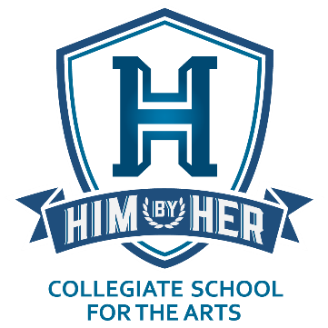

HIM By HER Collegiate School for the Arts
4501 East 32nd Street • Indianapolis, IN 46218
Phone: (317) 918-7799 • Email: info@himbyherschool.org
Website: www.himbyherschool.org

BOARD OF DIRECTORS

MINUTES OF THE DECEMBER 22, 2020 SCHOOL BOARD MEETING

The HIM By HER Collegiate School for the Arts (HBHCSA) School Board held its public school board meeting on Saturday, December 22, 2020 at the HIM By HER Foundation (HBHF) Headquarters/HIM By HER Collegiate School for the Arts (HBHCSA) Building (4501 East 32nd Street, Indianapolis, Indiana 46218).
Chairman John Bartlett called the meeting to order at 6:05 p.m. The following of eight (8) existing Board Members were in attendance: John Bartlett (Chair); Wayne Wellington (Vice Chair); Harry Dunn (President and Executive Director); Michelle Christian Dunn (Treasurer); Gregory Gadson (Secretary); James Leonard; and Keith White. Missing: Daryl Williams-Dotson. A quorum was present. Additional attendees: none.
Michelle Dunn gave the Treasurer’s Report. After motion and second, the Treasurer’s Report was unanimously accepted.
Harry Dunn gave the President’s Report, which led into a discussion under new business of two proposed resolutions. After motion and second, the Board unanimously adopted the two Resolutions appended to these Minutes.
Gregory Gadson gave the Secretary’s Report and presented the minutes of the December 5, 2020 HBHCSA Board meeting. After motion and second, the Secretary’s Report was unanimously accepted.
The next Board meeting will be January 9, 2021 at 11:30 a.m.
The meeting was adjourned at 6:28 p.m.

* * *

Attested to by:

/s/ Gregory P. Gadson
Gregory P. Gadson, Corporate Secretary
HIM By HER Foundation, Inc.
Date: December 22, 2020

HIM By HER Collegiate School for the Arts
4501 East 32nd Street • Indianapolis, IN 46218
Phone: (317) 918-7799 • Email: info@himbyherschool.org
Website: www.himbyherschool.org

BOARD OF DIRECTORS

RESOLUTIONS PASSED AT THE DECEMBER 22, 2020 SCHOOL BOARD MEETING

The HIM By HER Collegiate School for the Arts (HBHCSA) School Board, upon holding a duly noticed public Board Meeting at the HIM By HER Foundation (HBHF) Headquarters/HIM By HER Collegiate School for the Arts (HBHCSA) Building (4501 East 32nd Street, Indianapolis, Indiana 46218), with the presence of a quorum on December 22, 2020, voted on and passed with sufficient votes, the following Resolutions regarding the operation of HBHCSA:
First Adopted Resolution
The Board hereby resolves that HBHCSA shall: 1) immediately and formally seek emergency authority from its authorizer, Ball State University, the option to either expand the grade levels of the School served from the current Kindergarten through Second Grade to Kindergarten through Fifth Grade (the original charter request that was to be phased in over time) to start at the beginning of the second semester of the current academic year (which would commence January 4, 2021), or to start at the beginning of the first semester of the 2021-22 academic year (currently scheduled to commence August 17, 2021); and 2) seek authority from Ball State University, to have the option to expand the grade levels of the School served to additionally include Sixth Grade and Seventh Grade at the beginning of the first semester of the 2021-22 academic year if HBHCSA in its due diligence deems such expansion feasible.
Second Adopted Resolution
The Board hereby resolves that HBHCSA is authorized seek and formally acquire additional available funding from School House Development to help meet current budget shortfall projections for the continued operation of the School until additional funding sources are obtained in the Fall of 2021.

* * *

Attested to by:

/s/ Gregory P. Gadson
Gregory P. Gadson, Corporate Secretary
HIM By HER Foundation, Inc.

Date: December 22, 2020

